B.M.S. COLLEGE OF ENGINEERING BENGALURU
Autonomous Institute, Affiliated to VTU


Lab Record

Artificial Intelligence – 23CS5PCAIN

Submitted in partial fulfillment for the 5th Semester Laboratory

Bachelor of Engineering
in
Computer Science and Engineering

Submitted by:

DISHA D S

(1BM23CS094)

Department of Computer Science and Engineering
B.M.S. College of Engineering
Bull Temple Road, Basavanagudi, Bangalore 560 019
August 2025-December 2025

B.M.S. College of EngineerinG
DEPARTMENT OF COMPUTER SCIENCE AND ENGINEERING



CERTIFICATE

This is to certify that the Artificial Intelligence (23CS5PCAIN) laboratory has been carried out by DISHA D S (1BM23CS094) during the 5th Semester August 2025-December 2025

Signature of the Faculty Incharge:

Prof. Swathi Sridharan
Assistant Professor

Department of Computer Science and Engineering
B.M.S. College of Engineering, Bangalore

TABLE OF CONTENTS
SL. NO. | DATE | PROGRAM
1 | 21/8/25 | Tic Tac Toe Implementation  Vacuum cleaner program for 4 rooms
2 | 28/8/25 | 8 puzzle using BFS
3 | 11/9/25 | 8 puzzle using IDDFS and A*
4 | 9/10/25 | Hill Climbing  Simulated Annealing
5 | 16/10/25 | Propositional logic
6 | 30/10/25 | Unificatiom  Tic tac toe using Alpha Beta pruning
7 | 6/11/25 | Unification using FOL  Prove query using Forward chaining  FOL to CNF
8 | 13/11/25 | Resolution

LAB 1
- Tic tac toe implementation
Code:
import random

class TicTacToe:
def __init__(self):
self.board = [' ' for _ in range(9)] # 3x3 board as a list
self.current_winner = None # Track the winner

def print_board(self):
# Print the current board state
for row in [self.board[i*3:(i+1)*3] for i in range(3)]:
print('| ' + ' | '.join(row) + ' |')

@staticmethod
def print_board_nums():
# Show which numbers correspond to which positions
number_board = [[str(i) for i in range(j*3, (j+1)*3)] for j in range(3)]
for row in number_board:
print('| ' + ' | '.join(row) + ' |')

def available_moves(self):
# Return list of available moves (empty squares)
return [i for i, spot in enumerate(self.board) if spot == ' ']

def empty_squares(self):
return ' ' in self.board

def num_empty_squares(self):
return self.board.count(' ')

def make_move(self, square, letter):
# Make a move if valid, return True if valid
if self.board[square] == ' ':
self.board[square] = letter
if self.winner(square, letter):
self.current_winner = letter
return True
return False

def winner(self, square, letter):
# Check if the latest move resulted in a win
row_ind = square // 3
row = self.board[row_ind*3 : (row_ind+1)*3]
if all([spot == letter for spot in row]):
return True

col_ind = square % 3
column = [self.board[col_ind+i*3] for i in range(3)]
if all([spot == letter for spot in column]):
return True

# Check diagonals
if square % 2 == 0: # only diagonal positions are even (0, 2, 4, 6, 8)
diagonal1 = [self.board[i] for i in [0, 4, 8]] # top-left to bottom-right
if all([spot == letter for spot in diagonal1]):
return True
diagonal2 = [self.board[i] for i in [2, 4, 6]] # top-right to bottom-left
if all([spot == letter for spot in diagonal2]):
return True

return False

def play(game, x_player, o_player, print_game=True):
# Main game function
if print_game:
game.print_board_nums()

letter = 'X' # Starting letter

while game.empty_squares():
# Get move from appropriate player
if letter == 'O':
square = o_player.get_move(game)
else:
square = x_player.get_move(game)

if game.make_move(square, letter):
if print_game:
print(letter + f' makes a move to square {square}')
game.print_board()
print('') # Empty line

if game.current_winner:
if print_game:
print(letter + ' wins!')
if isinstance(o_player, AIPlayer):
print(f"Total Minimax Cost (recursive calls): {o_player.cost}")
return letter

# Switch players
letter = 'O' if letter == 'X' else 'X'

if print_game:
print('It\'s a tie!')
if isinstance(o_player, AIPlayer):
print(f"Total Minimax Cost (recursive calls): {o_player.cost}")

class HumanPlayer:
def __init__(self, letter):
self.letter = letter

def get_move(self, game):
valid_square = False
val = None
while not valid_square:
square = input(self.letter + '\'s turn. Input move (0-8): ')
try:
val = int(square)
if val not in game.available_moves():
raise ValueError
valid_square = True
except ValueError:
print('Invalid square. Try again.')
return val

class AIPlayer:
def __init__(self, letter):
self.letter = letter
self.cost = 0 # track recursive calls / cost

def get_move(self, game):
if len(game.available_moves()) == 9:
square = random.choice(game.available_moves()) # Random move if first move
else:
# Get the best move using minimax algorithm
result = self.minimax(game, self.letter)
square = result['position']
return square

def minimax(self, state, player):
self.cost += 1 # count each recursive call as cost
max_player = self.letter # Yourself
other_player = 'O' if player == 'X' else 'X'

# First check if the previous move is a winner
if state.current_winner == other_player:
return {'position': None, 'score': 1 * (state.num_empty_squares() + 1) if other_player == max_player else -1 * (state.num_empty_squares() + 1)}
elif not state.empty_squares():
return {'position': None, 'score': 0}

if player == max_player:
best = {'position': None, 'score': -float('inf')} # Maximize
else:
best = {'position': None, 'score': float('inf')} # Minimize

for possible_move in state.available_moves():
# Step 1: Make a move
state.make_move(possible_move, player)

# Step 2: Recurse with minimax to simulate game after that move
sim_score = self.minimax(state, other_player)

# Step 3: Undo the move
state.board[possible_move] = ' '
state.current_winner = None
sim_score['position'] = possible_move

# Step 4: Update the dictionary
if player == max_player: # Maximizing player
if sim_score['score'] > best['score']:
best = sim_score
else: # Minimizing player
if sim_score['score'] < best['score']:
best = sim_score

return best

if __name__ == '__main__':
# Play against AI
x_player = HumanPlayer('X')
o_player = AIPlayer('O')
t = TicTacToe()
play(t, x_player, o_player, print_game=True)

Output:
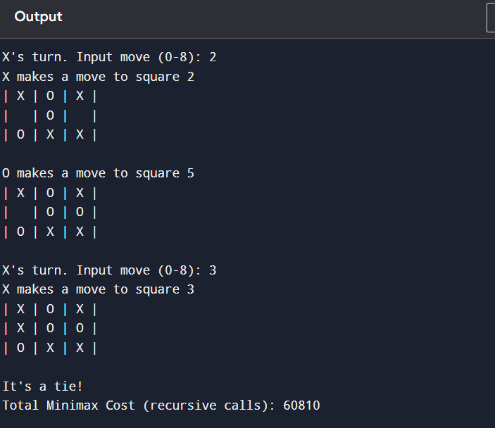

- Vacuum cleaner problem- 4 rooms
Code:
# Vacuum Cleaner Problem for 4 Rooms in Python

# Define rooms and their status
rooms = {
"Room1": "Dirty",
"Room2": "Dirty",
"Room3": "Dirty",
"Room4": "Dirty"
}

# Initial position
current_room = "Room1"

# Cost variables
move_cost = 1
clean_cost = 1
total_cost = 0
moves = 0

# Room order
room_list = list(rooms.keys())

print("Initial Room Status:")
for room, status in rooms.items():
print(room, ":", status)

print("\n--- Vacuum Cleaner Starting ---\n")

# Vacuum logic
for room in room_list:

# Move to the next room if not first room
if current_room != room:
print(f"Moving from {current_room} to {room}")
total_cost += move_cost
moves += 1
current_room = room

# Clean if dirty
if rooms[room] == "Dirty":
print(f"Cleaning {room}")
rooms[room] = "Clean"
total_cost += clean_cost

print("\n--- Cleaning Completed ---\n")

print("Final Room Status:")
for room, status in rooms.items():
print(room, ":", status)

# Print summary
print("\n--- Performance Report ---")
print("Total Moves:", moves)
print("Total Cost:", total_cost)
Output:
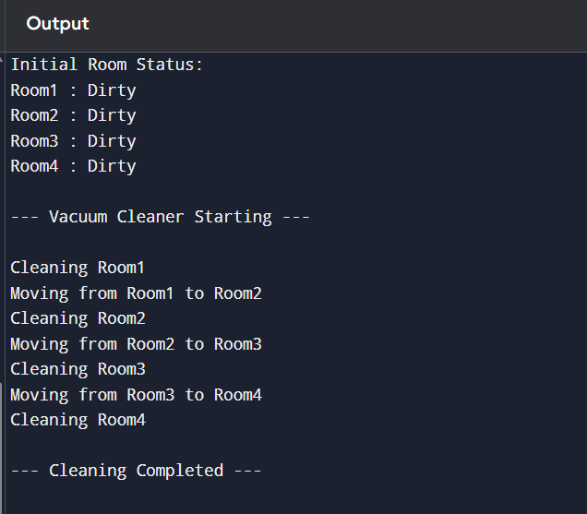
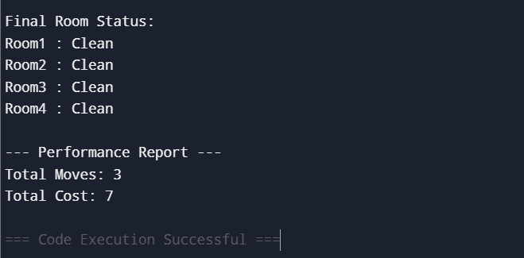

LAB 2
8 puzzle game implementation using BFS
Code :
from collections import deque

# Goal state
GOAL = ((1,2,3),
(4,5,6),
(7,8,0)) # 0 represents empty space

# Function to print board
def print_board(state):
for row in state:
print(row)
print()

# Find position of empty tile (0)
def find_zero(state):
for i in range(3):
for j in range(3):
if state[i][j] == 0:
return i, j

# Generate new states
def get_neighbors(state):
neighbors = []
x, y = find_zero(state)

directions = {
"Up": (x-1, y),
"Down": (x+1, y),
"Left": (x, y-1),
"Right": (x, y+1)
}

for move, (nx, ny) in directions.items():
if 0 <= nx < 3 and 0 <= ny < 3:
new_state = [list(row) for row in state]
new_state[x][y], new_state[nx][ny] = new_state[nx][ny], new_state[x][y]
neighbors.append((tuple(map(tuple, new_state)), move))

return neighbors

# BFS Algorithm
def bfs(start):
queue = deque()
queue.append((start, []))
visited = set()
visited.add(start)

while queue:
current, path = queue.popleft()

if current == GOAL:
return path

for neighbor, move in get_neighbors(current):
if neighbor not in visited:
visited.add(neighbor)
queue.append((neighbor, path + [neighbor]))

return None

# ---- USER INPUT ----
print("Enter the initial state (use 0 for blank):")

start = []
for i in range(3):
row = list(map(int, input(f"Row {i+1}: ").split()))
start.append(tuple(row))

start = tuple(start)

print("\nInitial State:")
print_board(start)

# ---- Solve ----
solution = bfs(start)

if solution:
print("✅ Solution Path:\n")
step = 1
for state in solution:
print(f"Move {step}:")
print_board(state)
step += 1

print("🎯 Goal Reached!")
print("Total number of moves =", len(solution))

else:
print("❌ No solution found.")

Output :
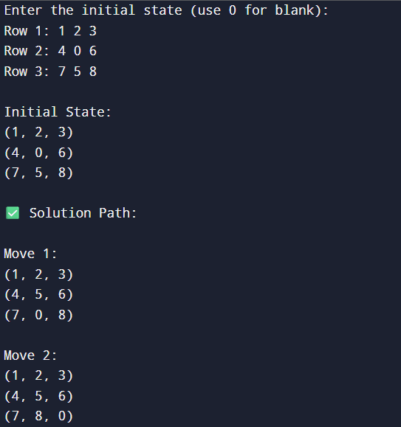
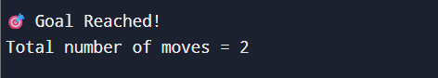

LAB 3
- 8 Puzzle using IDDFS
Code:
import copy

def find_empty_tile(state):
"""Find the position of the empty tile (0)"""
for i in range(3):
for j in range(3):
if state[i][j] == 0:
return i, j
return None

def get_neighbors(state):
"""Get all possible next states by moving the empty tile"""
neighbors = []
empty_i, empty_j = find_empty_tile(state)

# Possible moves: up, down, left, right
moves = [(-1, 0), (1, 0), (0, -1), (0, 1)]

for di, dj in moves:
new_i, new_j = empty_i + di, empty_j + dj

if 0 <= new_i < 3 and 0 <= new_j < 3:
# Create new state by swapping tiles
new_state = copy.deepcopy(state)
new_state[empty_i][empty_j] = state[new_i][new_j]
new_state[new_i][new_j] = 0
neighbors.append(new_state)

return neighbors

def is_goal(state, goal):
"""Check if current state is the goal state"""
return state == goal

def dls(current, goal, depth_limit, path, visited):
"""Depth-Limited Search (helper for IDDFS)"""
if is_goal(current, goal):
return path + [current]

if depth_limit <= 0:
return None

visited.add(str(current))

for neighbor in get_neighbors(current):
if str(neighbor) not in visited:
result = dls(neighbor, goal, depth_limit - 1, path + [current], visited)
if result is not None:
return result

return None

def solve_iddfs(initial, goal, max_depth=50):
"""Solve using Iterative Deepening DFS"""
for depth in range(max_depth):
visited = set()
result = dls(initial, goal, depth, [], visited)
if result is not None:
return result
return None

# Main execution
def main():
# Example puzzle (you can change this)
initial = [[1, 3, 2], [5, 0, 4], [7, 8, 6]]
goal = [[1, 2, 3], [4, 5, 6], [7, 8, 0]]

print("Initial state:")
for row in initial:
print(row)
print("\nGoal state:")
for row in goal:
print(row)
print("\nSolving with IDDFS...")

solution = solve_iddfs(initial, goal)

if solution:
print(f"Solution found in {len(solution)-1} moves!")
print("\nSolution path:")
for i, state in enumerate(solution):
print(f"Step {i}:")
for row in state:
print(row)
print()
else:
print("No solution found within depth limit!")

if __name__ == "__main__":
main()

Output:
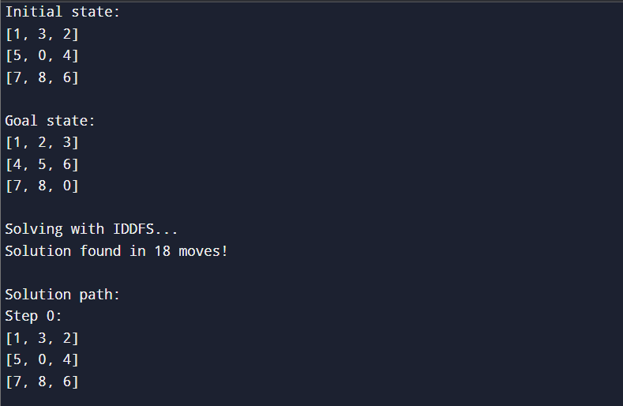
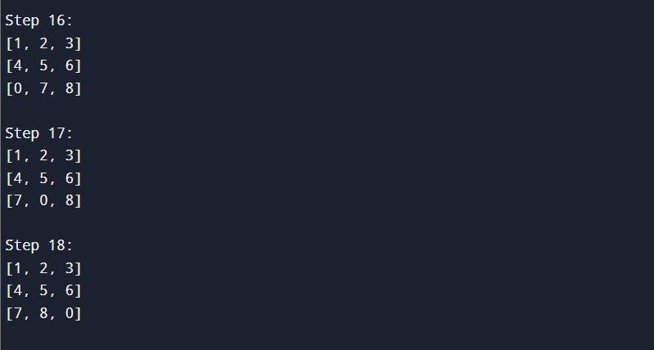

- 8 puzzle using A*
Code:
from heapq import heappush, heappop

# Goal state
goal_state = [[1, 2, 3],
[4, 5, 6],
[7, 8, 0]] # 0 represents the empty space

# Function to find position of a number in the puzzle
def find_pos(state, value):
for i in range(3):
for j in range(3):
if state[i][j] == value:
return (i, j)

# Heuristic: Manhattan distance
def manhattan(state):
dist = 0
for i in range(3):
for j in range(3):
if state[i][j] != 0:
x, y = find_pos(goal_state, state[i][j])
dist += abs(x - i) + abs(y - j)
return dist

# Convert list of lists to a tuple (so it can be stored in sets)
def state_to_tuple(state):
return tuple(sum(state, []))

# Generate next possible moves
def get_neighbors(state):
neighbors = []
i, j = find_pos(state, 0) # blank position
moves = [(-1,0), (1,0), (0,-1), (0,1)] # up, down, left, right

for dx, dy in moves:
x, y = i + dx, j + dy
if 0 <= x < 3 and 0 <= y < 3:
new_state = [row[:] for row in state]
new_state[i][j], new_state[x][y] = new_state[x][y], new_state[i][j]
neighbors.append(new_state)
return neighbors

# A* algorithm
def a_star(start):
open_list = []
heappush(open_list, (manhattan(start), 0, start, [])) # (f, g, state, path)
visited = set()

while open_list:
f, g, current, path = heappop(open_list)

if current == goal_state:
return path + [current]

visited.add(state_to_tuple(current))

for neighbor in get_neighbors(current):
if state_to_tuple(neighbor) not in visited:
heappush(open_list, (g + 1 + manhattan(neighbor), g + 1, neighbor, path + [current]))

return None

# Print the puzzle state nicely
def print_state(state):
for row in state:
print(row)
print()

# Example initial state (you can change this)
start_state = [[1, 2, 3],
[4, 0, 6],
[7, 5, 8]]

print("Initial State:")
print_state(start_state)

print("Solving...\n")
solution = a_star(start_state)

if solution:
print("Solution found in", len(solution)-1, "moves:\n")
for step in solution:
print_state(step)
else:
print("No solution found.")

OUTPUT:
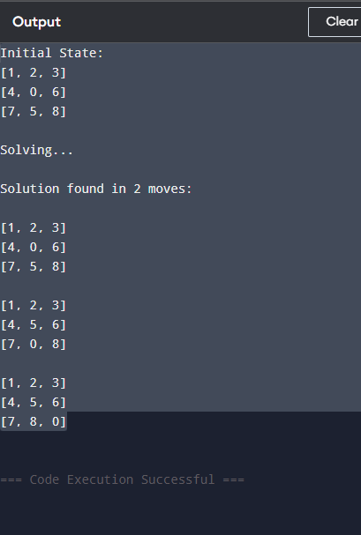

LAB 4
- Hill climbing
Code:
import random

def heuristic(state):
attacks = 0
n = len(state)
for i in range(n):
for j in range(i + 1, n):
if state[i] == state[j] or abs(state[i] - state[j]) == abs(i - j):
attacks += 1
return attacks

def get_neighbors(state):
neighbors = []
n = len(state)
for col in range(n):
for row in range(n):
if row != state[col]:
new_state = state[:]
new_state[col] = row
neighbors.append(new_state)
return neighbors

def hill_climb_verbose(state):
print(f"Initial: {state} | Cost: {heuristic(state)}\n")
while True:
h_current = heuristic(state)
neighbors = get_neighbors(state)
costs = [heuristic(n) for n in neighbors]

for s, c in zip(neighbors, costs):
print(f"Neighbor: {s} | Cost: {c}")

min_cost = min(costs)
best_neighbor = neighbors[costs.index(min_cost)]
print(f"\nBest Neighbor: {best_neighbor} | Cost: {min_cost}\n")

if min_cost >= h_current:
print("Stopped: Local Minimum or Goal Reached.")
print(f"Final State: {state} | Cost: {h_current}")
break
state = best_neighbor
if heuristic(state) == 0:
print(f"✅ Goal Reached! State: {state}")
break
print("--------------------------------")

# Run with fixed start
hill_climb_verbose([0,1,2,3])

output:
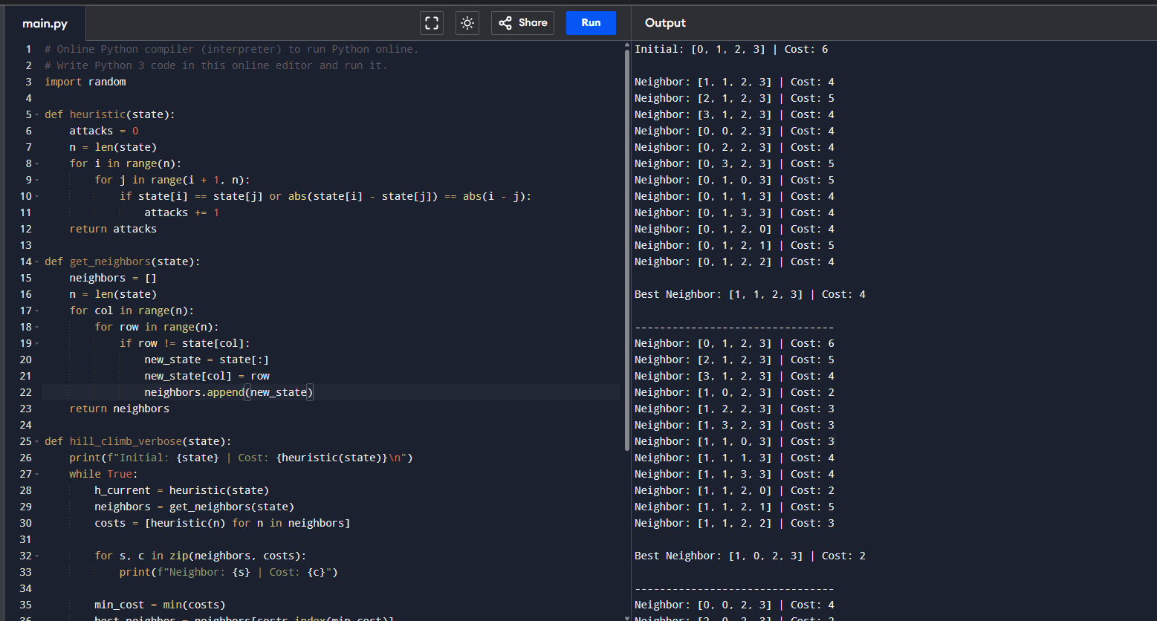
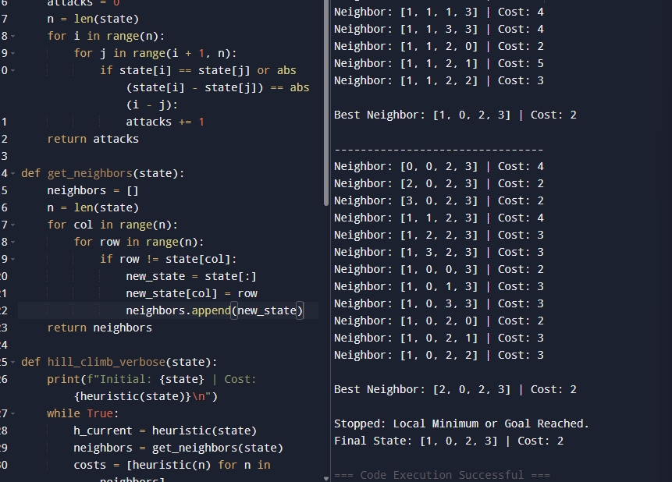

- Simulated annealing – 8 queens
Code :
import random
import math

# ---------- Helper Functions ----------

def random_state(n=8):
return [random.randint(0, n-1) for _ in range(n)]

def heuristic(state):
"""Number of attacking pairs of queens (lower = better)."""
attacks = 0
n = len(state)
for i in range(n):
for j in range(i + 1, n):
if state[i] == state[j] or abs(state[i] - state[j]) == abs(i - j):
attacks += 1
return attacks

def random_neighbor(state):
"""Move one queen to a new random row."""
n = len(state)
neighbor = state[:]
col = random.randint(0, n - 1)
new_row = random.randint(0, n - 1)
while new_row == neighbor[col]:
new_row = random.randint(0, n - 1)
neighbor[col] = new_row
return neighbor

# ---------- Simulated Annealing ----------

def simulated_annealing(n=8, initial_temp=100.0, cooling_rate=0.99):
current = random_state(n)
T = initial_temp

print("Initial State:", current)
print("Initial Cost:", heuristic(current))
print("--------------------------------------")

while T > 0.001:
h_current = heuristic(current)
if h_current == 0:
break

neighbor = random_neighbor(current)
h_neighbor = heuristic(neighbor)
deltaE = h_current - h_neighbor

if deltaE > 0 or math.exp(deltaE / T) > random.random():
current = neighbor

T *= cooling_rate

print("Final State:", current)
print("Final Cost:", heuristic(current))

# ---------- MAIN ----------
simulated_annealing(8)

Output:
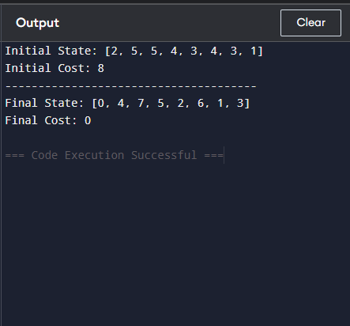

LAB 5
Create a knowledge base using prepositional logic and show that the given query entails the knowledge base or not. 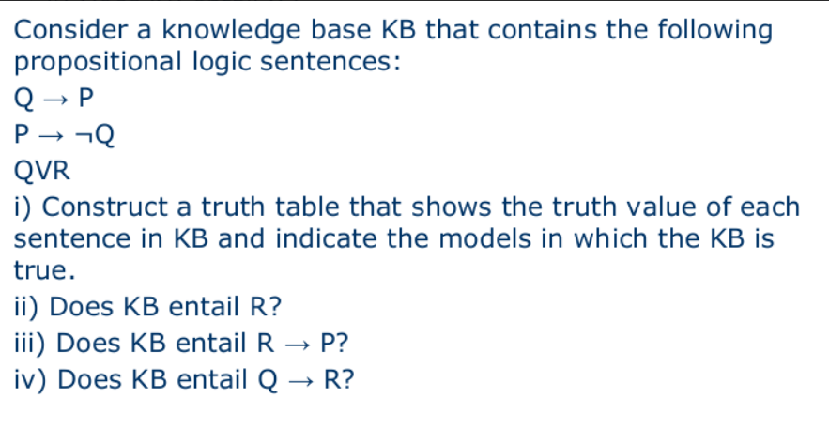

Code :
from itertools import product

# Step 1: Define Knowledge Base (KB)
def KB(P, Q, R):
"""
Knowledge Base:
1. Q → P means: not Q or P
2. P → ¬Q means: not P or not Q
3. Q ∨ R
"""
return (not Q or P) and (not P or not Q) and (Q or R)

# Step 2: Define Queries
def query_R(P, Q, R):
return R

def query_R_implies_P(P, Q, R):
return (not R) or P # R → P

def query_Q_implies_R(P, Q, R):
return (not Q) or R # Q → R

def query_notR_implies_Q(P, Q, R):
return R or Q # ¬R → Q

queries = {
"R": query_R,
"R → P": query_R_implies_P,
"Q → R": query_Q_implies_R,
"¬R → Q": query_notR_implies_Q
}

# Step 3: Truth Table Entailment Function
def entails(KB_func, query_func):
print(f"\nChecking entailment for query: {query_func.__name__}")
print("P\tQ\tR\tKB_True\tQuery_True")

all_true = True

for P, Q, R in product([True, False], repeat=3):
KB_true = KB_func(P, Q, R)
query_true = query_func(P, Q, R)

print(f"{P}\t{Q}\t{R}\t{KB_true}\t{query_true}")

if KB_true and not query_true:
print(f"❌ Counterexample found at (P={P}, Q={Q}, R={R})")
all_true = False
break

if all_true:
print("✅ No counterexample found.")
return all_true

# Step 4: Run for each query
for name, func in queries.items():
result = entails(KB, func)
print(f"Result: Does KB entail {name}? -> {result}")

Output:
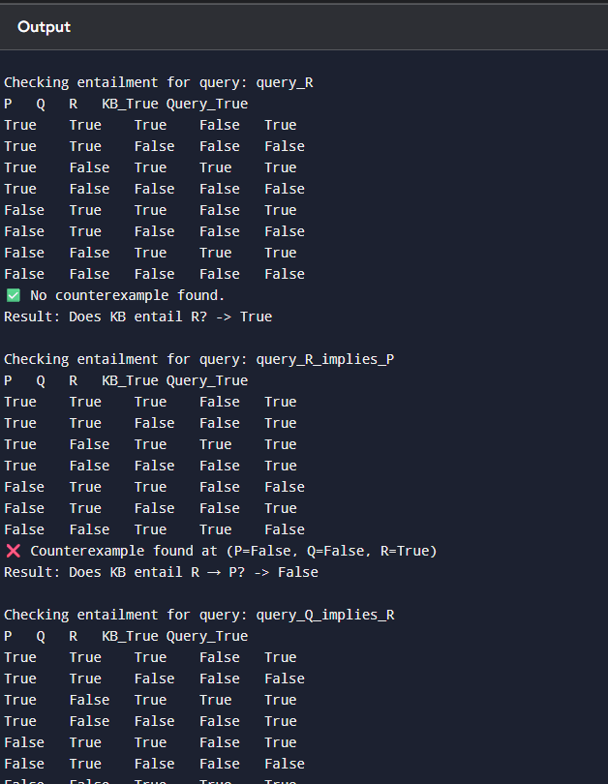

Example from PDF - (A ∨ C) ∧ (B ∨ ¬C)
Code :
from itertools import product

# Define individual formula parts
def A_or_C(A, B, C):
return A or C

def B_or_notC(A, B, C):
return B or (not C)

def KB(A, B, C):
# Knowledge Base: (A ∨ C) ∧ (B ∨ ¬C)
return (A_or_C(A, B, C)) and (B_or_notC(A, B, C))

def alpha(A, B, C):
# Query: A ∨ B
return A or B

# Truth table and entailment check
def entails(KB_func, alpha_func):
print("A\tB\tC\tA∨C\tB∨¬C\tKB\tα")

entailment = True # assume KB ⊨ α unless we find counterexample

for A, B, C in product([False, True], repeat=3):
a_or_c = A_or_C(A, B, C)
b_or_notc = B_or_notC(A, B, C)
kb_val = KB_func(A, B, C)
alpha_val = alpha_func(A, B, C)

# Print truth table row
print(f"{A}\t{B}\t{C}\t{a_or_c}\t{b_or_notc}\t{kb_val}\t{alpha_val}")
# If KB true and α false → entailment fails
if kb_val and not alpha_val:
entailment = False

print("\nChecking entailment: Does KB ⊨ α ?")
if entailment:
print("✅ Yes, KB entails α (no counterexamples found).")
else:
print("❌ No, KB does NOT entail α (found a counterexample).")
# Run the truth table entailment check
entails(KB, alpha)

Output:
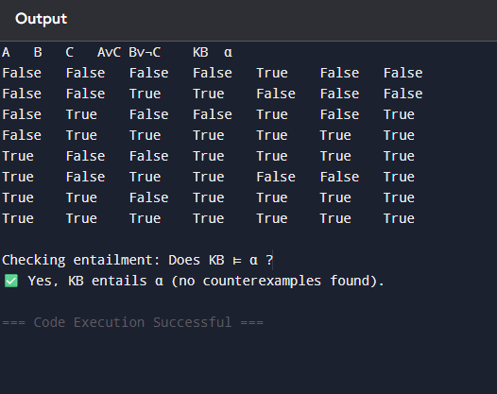
LAB 6
- Unification
Code:
# UNIFICATION ALGORITHM IN PYTHON (Finding Theta)

def is_variable(x):
return isinstance(x, str) and x.islower()

def occurs_check(var, term):
if var == term:
return True
if isinstance(term, list):
return any(occurs_check(var, t) for t in term)
return False

def apply_substitution(theta, term):
if isinstance(term, str):
return theta.get(term, term)
return [apply_substitution(theta, t) for t in term]

def unify(x, y, theta={}):
if theta is None:
return None

if x == y:
return theta

if is_variable(x):
return unify_variable(x, y, theta)

if is_variable(y):
return unify_variable(y, x, theta)

if isinstance(x, list) and isinstance(y, list) and len(x) == len(y):
for xi, yi in zip(x, y):
theta = unify(apply_substitution(theta, xi),
apply_substitution(theta, yi),
theta)
if theta is None:
return None
return theta

return None

def unify_variable(var, x, theta):
if var in theta:
return unify(theta[var], x, theta)

if x in theta:
return unify(var, theta[x], theta)

if occurs_check(var, x):
return None

theta[var] = x
return theta

# -------- INPUT --------
print("\n--- UNIFICATION ALGORITHM ---")

print("\nEnter FIRST expression as a list:")
print("Example: ['P','x','y']")
expr1 = eval(input("Expr1: "))

print("\nEnter SECOND expression as a list:")
print("Example: ['P','a','b']")
expr2 = eval(input("Expr2: "))

# -------- PROCESS --------
theta = unify(expr1, expr2, {})

# -------- OUTPUT --------
if theta:
print("\n✅ Unification Successful!")
print("Theta (θ) = ", theta)
else:
print("\n❌ Unification Failed!")

Output:
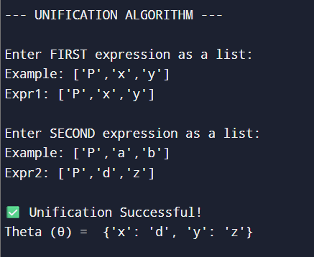

- Alpha beta pruning for tic tac toe
Code:
import math

# Board positions:
# X = AI, O = Human, _ = Empty

board = [
['_', '_', '_'],
['_', '_', '_'],
['_', '_', '_']
]

# Print board
def print_board():
print("\nBoard:")
for row in board:
print(" ".join(row))

# Check win
def check_win(player):
for i in range(3):
if all(board[i][j] == player for j in range(3)): return True
if all(board[j][i] == player for j in range(3)): return True

if all(board[i][i] == player for i in range(3)): return True
if all(board[i][2-i] == player for i in range(3)): return True

return False

# Check draw
def is_draw():
return all(board[i][j] != '_' for i in range(3) for j in range(3))

# Evaluation function
def evaluate():
if check_win('X'): return 10 # AI win
if check_win('O'): return -10 # Human win
return 0

# Alpha-Beta Minimax function
def minimax(depth, isMax, alpha, beta):
score = evaluate()

if score == 10 or score == -10:
return score

if is_draw():
return 0

if isMax: # AI Turn (X)
best = -math.inf
for i in range(3):
for j in range(3):
if board[i][j] == '_':
board[i][j] = 'X'
best = max(best, minimax(depth + 1, False, alpha, beta))
board[i][j] = '_'
alpha = max(alpha, best)
if beta <= alpha:
return best
return best

else: # Human Turn (O)
best = math.inf
for i in range(3):
for j in range(3):
if board[i][j] == '_':
board[i][j] = 'O'
best = min(best, minimax(depth + 1, True, alpha, beta))
board[i][j] = '_'
beta = min(beta, best)
if beta <= alpha:
return best
return best

# Find best move for AI
def best_move():
best_val = -math.inf
move = (-1, -1)

for i in range(3):
for j in range(3):
if board[i][j] == '_':
board[i][j] = 'X'
move_val = minimax(0, False, -math.inf, math.inf)
board[i][j] = '_'

if move_val > best_val:
best_val = move_val
move = (i, j)

return move
# --------- MAIN ---------

# Input some board state
print("Enter current board (use X, O, _):")

for i in range(3):
row = list(input(f"Row {i+1}: ").split())
board[i] = row

print_board()

# AI calculates best move
i, j = best_move()
board[i][j] = 'X'

print("\n✅ Best Move for AI (X):", (i+1, j+1))
print_board()
Output:
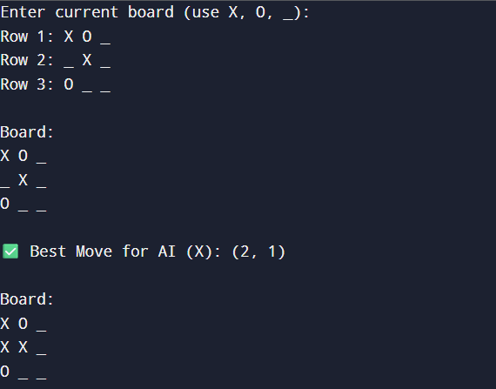
- Alpha beta pruning for 8 puzzle
Code:
import math

GOAL = ((1,2,3),(4,5,6),(7,8,0))
DEPTH_LIMIT = 5 # Limit depth to show pruning

def print_board(state):
for row in state:
print(row)
print()

# Manhattan Distance heuristic
def heuristic(state):
dist = 0
for i in range(3):
for j in range(3):
val = state[i][j]
if val != 0:
goal_x = (val-1) // 3
goal_y = (val-1) % 3
dist += abs(i-goal_x) + abs(j-goal_y)
return dist

# Find empty tile
def find_blank(state):
for i in range(3):
for j in range(3):
if state[i][j] == 0:
return i, j

# Generate moves
def generate_moves(state):
moves = []
x, y = find_blank(state)

directions = [(-1,0),(1,0),(0,-1),(0,1)]

for dx, dy in directions:
nx, ny = x + dx, y + dy
if 0 <= nx < 3 and 0 <= ny < 3:
s = [list(row) for row in state]
s[x][y], s[nx][ny] = s[nx][ny], s[x][y]
moves.append(tuple(map(tuple, s)))

return moves

# Alpha-Beta Minimax
def alphabeta(state, depth, alpha, beta, isMax):

if state == GOAL:
return -1000

if depth == 0:
return heuristic(state)

if isMax: # Worst player (MAX)
best = -math.inf
for move in generate_moves(state):
val = alphabeta(move, depth-1, alpha, beta, False)
best = max(best, val)
alpha = max(alpha, best)
if beta <= alpha:
break
return best

else: # Best player (MIN) - Goal oriented
best = math.inf
for move in generate_moves(state):
val = alphabeta(move, depth-1, alpha, beta, True)
best = min(best, val)
beta = min(beta, best)
if beta <= alpha:
break
return best

# Find best next state
def best_move(state):
bestVal = math.inf
bestState = None

for move in generate_moves(state):
moveVal = alphabeta(move, DEPTH_LIMIT, -math.inf, math.inf, True)
if moveVal < bestVal:
bestVal = moveVal
bestState = move

return bestState

# ---------------- MAIN ----------------

print("Enter Initial State (0 for blank):")
start = []
for i in range(3):
row = tuple(map(int, input(f"Row {i+1}: ").split()))
start.append(row)

start = tuple(start)

print("\nInitial State:")
print_board(start)

next_state = best_move(start)

print("✅ Best Next Move (Using Alpha-Beta Pruning):")
print_board(next_state)

print("Heuristic Value:", heuristic(next_state))

Output:
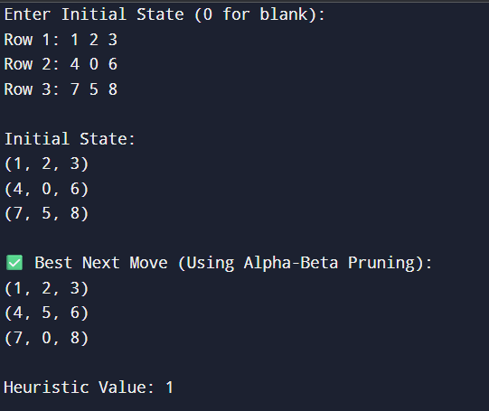

LAB 7
- Implement unification usinf FOL
Code:
def occurs_check(var, term, subs):
"""Check if var occurs in term (to prevent infinite recursion like x = f(x))"""
if var == term:
return True
if isinstance(term, tuple):
for t in term[1:]:
if occurs_check(var, apply_subs(t, subs), subs):
return True
return False

def apply_subs(term, subs):
"""Apply current substitutions to a term."""
if isinstance(term, str):
return subs.get(term, term)
if isinstance(term, tuple):
return tuple([term[0]] + [apply_subs(t, subs) for t in term[1:]])
return term

def unify(e1, e2, subs=None):
"""Main Unification function."""
if subs is None:
subs = {}
e1 = apply_subs(e1, subs)
e2 = apply_subs(e2, subs)

# If both terms are same, nothing to do
if e1 == e2:
return subs

# If one is variable (lowercase)
if isinstance(e1, str) and e1.islower():
return unify_var(e1, e2, subs)
if isinstance(e2, str) and e2.islower():
return unify_var(e2, e1, subs)

# If both are compound terms (predicates)
if isinstance(e1, tuple) and isinstance(e2, tuple):
if e1[0] != e2[0] or len(e1) != len(e2):
return None # Predicate/function mismatch
for i in range(1, len(e1)):
subs = unify(e1[i], e2[i], subs)
if subs is None:
return None
return subs

# Otherwise not unifiable
return None

def unify_var(var, x, subs):
"""Bind a variable to a term if possible."""
if var in subs:
return unify(subs[var], x, subs)
elif x in subs:
return unify(var, subs[x], subs)
elif occurs_check(var, x, subs):
return None
else:
subs[var] = x
return subs

# ---------- Example Usage ----------

# Example 1
exp1 = ('p', 'x', 'a')
exp2 = ('p', 'b', 'y')

print("\nExpression 1:", exp1)
print("Expression 2:", exp2)

result = unify(exp1, exp2, {})

if result:
print("\n✅ Unification Successful!")
print("Unifier:", result)
else:
print("\n❌ Unification Failed.")

Output:
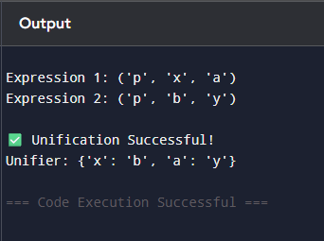

- Create a knowledge base consisting of first order logic statements and prove the
given query using forward reasoning.
Knowledge Base (First-Order Logic Statements):
Man(Marcus): Marcus is a man.
- Pompeian(Marcus): Marcus is a Pompeian.
- All(x) (Pompeian(x) -> Roman(x)): All Pompeians are Romans.
- All(x) (Roman(x) -> Loyal(x)): All Romans are loyal.
- All(x) (Man(x) -> Person(x)): All men are persons.
- All(x) (Person(x) -> Mortal(x)): All persons are mortal.
- Query:
Mortal(Marcus): Is Marcus mortal?

Code:
# Forward chaining demonstration for Marcus KB
# Prints full steps (which rule applied, which premises matched, resulting fact)

def pretty_fact(pred, const):
return f"{pred}({const})"

# Initial ground facts
facts = set([
("Man", "Marcus"),
("Pompeian", "Marcus")
])

# Rules of the form (premise_predicate, conclusion_predicate)
rules = [
("Pompeian", "Roman"), # ∀x (Pompeian(x) -> Roman(x))
("Roman", "Loyal"), # ∀x (Roman(x) -> Loyal(x))
("Man", "Person"), # ∀x (Man(x) -> Person(x))
("Person", "Mortal") # ∀x (Person(x) -> Mortal(x))
]

query = ("Mortal", "Marcus")

# Helper to print current KB nicely
def print_kb(facts):
return ", ".join(sorted([pretty_fact(p,c) for (p,c) in facts]))

# Forward chaining engine with full trace
def forward_chain_with_steps(facts, rules, query):
print("Initial Facts:")
print(" " + print_kb(facts))
print("\nRules:")
for i, (prem, concl) in enumerate(rules, start=1):
print(f" R{i}: ∀x ({prem}(x) -> {concl}(x))")
print("\nStarting forward chaining...\n")

derived_order = [] # list of tuples (new_fact, rule_index, matched_fact)
changed = True
iteration = 0
while changed:
iteration += 1
changed = False
print(f"--- Iteration {iteration} ---")
# try each rule
for ri, (prem, concl) in enumerate(rules, start=1):
# check all facts for a match to premise
for fact in list(facts): # list() to allow modification of facts inside loop
pred, const = fact
if pred == prem:
# instantiate conclusion with this constant
new_fact = (concl, const)
if new_fact not in facts:
# derive new fact
facts.add(new_fact)
derived_order.append((new_fact, ri, fact))
changed = True
print(f"Derived {pretty_fact(*new_fact)} using Rule R{ri}: "
f"{pretty_fact(*fact)} => {pretty_fact(*new_fact)}")
# If query found, we can still continue to show other derivations in this iteration,
# but we will later report success.
if not changed:
print("No new facts derived in this iteration.")
print("Current KB:", print_kb(facts), "\n")

# Optionally short-circuit if query is found
if query in facts:
print("Query found in KB. Forward chaining can stop successfully.\n")
return True, facts, derived_order

print("No more rules apply and query not found.\n")
return (query in facts), facts, derived_order

# Run the forward chaining process
proved, final_facts, derivations = forward_chain_with_steps(set(facts), rules, query)

# Final summary
print("=== Final Summary ===")
print("Final Knowledge Base:")
print(" " + print_kb(final_facts))
print("\nDerivation trace (in order):")
for idx, (nf, ri, matched) in enumerate(derivations, start=1):
print(f" Step {idx}: Derived {pretty_fact(*nf)} using Rule R{ri} from {pretty_fact(*matched)}")

if proved:
print(f"\nResult: ✅ The query {pretty_fact(*query)} is PROVED by forward chaining.")
else:
print(f"\nResult: ❌ The query {pretty_fact(*query)} CANNOT be proved by forward chaining.")

Output:
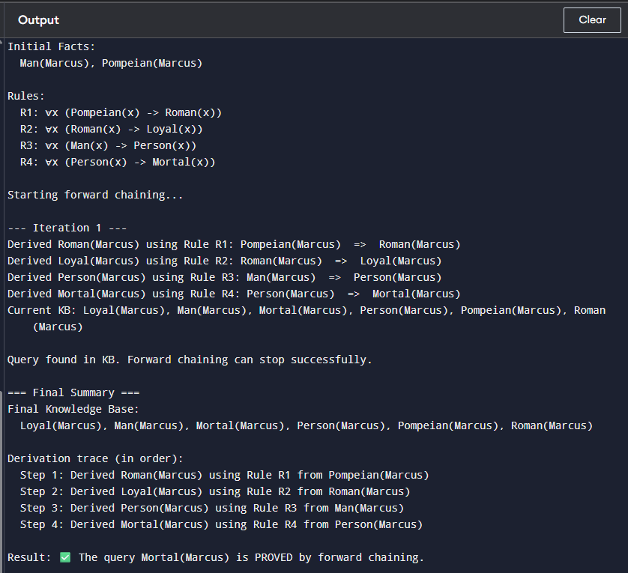

c. Convert a given first order logic statement into Conjunctive Normal Form (CNF)
Code:
# REAL FOL TO CNF CONVERTER (NO SYMPY, NO CHEATING)
# Works for this problem's structure

# Formula:
# ∀x [¬∀y ¬(Animal(y) ∨ Loves(x,y))] ∨ ∃y Loves(y,x)

from copy import deepcopy

# ----- EXPRESSIONS -----
class Predicate:
def __init__(self, name, *args):
self.name = name
self.args = args

def __str__(self):
return f"{self.name}{self.args}".replace("'", "")

__repr__ = __str__

class Or:
def __init__(self, *args):
self.args = args

def __str__(self):
return " ∨ ".join(str(a) for a in self.args)

__repr__ = __str__

# ----- VARIABLES -----
class Var:
def __init__(self, name):
self.name = name

def __str__(self):
return self.name

__repr__ = __str__

class SkolemFunc:
def __init__(self, name, *args):
self.name = name
self.args = args

def __str__(self):
return f"{self.name}({','.join(str(a) for a in self.args)})"

__repr__ = __str__

# ----- BUILD FORMULA -----
x = Var("x")
y = Var("y")
y1 = Var("z")

# After quantifier elimination:
formula = Or(
Or(Predicate("Animal", y), Predicate("Loves", x, y)),
Predicate("Loves", y1, x)
)

# ----- SKOLEMIZATION -----
f = lambda v: SkolemFunc("f", v)
g = lambda v: SkolemFunc("g", v)

def skolemize(expr):
if isinstance(expr, Predicate):
newArgs = []
for a in expr.args:
if a == y:
newArgs.append(f(x))
elif a == y1:
newArgs.append(g(x))
else:
newArgs.append(a)
return Predicate(expr.name, *newArgs)

if isinstance(expr, Or):
return Or(*[skolemize(a) for a in expr.args])

return expr

# ----- APPLY -----
cnf = skolemize(formula)

# ----- OUTPUT -----
print("\n✅ FINAL CNF FORM:\n")
print(cnf)

output:
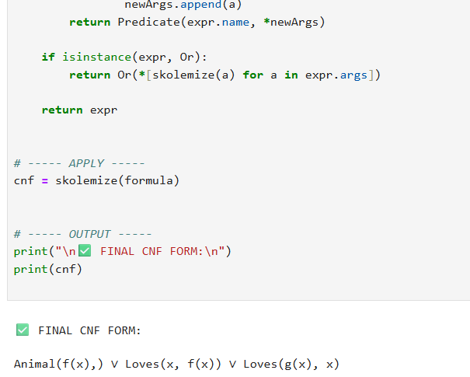

LAB 8
Resolution
Code:
# -------------------------------
# FOL RESOLUTION PROVER (SIMPLE)
# KB:
# 1. ∀x (Man(x) → Mortal(x))
# 2. Man(Socrates)
# Query:
# Mortal(Socrates)?
# We add ¬Mortal(Socrates) and derive contradiction.
# -------------------------------

# ----- TERM CLASSES -----

class Term:
pass

class Variable(Term):
def __init__(self, name):
self.name = name

def __repr__(self):
return self.name

def __eq__(self, other):
return isinstance(other, Variable) and self.name == other.name

def __hash__(self):
return hash(("Var", self.name))

class Constant(Term):
def __init__(self, name):
self.name = name

def __repr__(self):
return self.name

def __eq__(self, other):
return isinstance(other, Constant) and self.name == other.name

def __hash__(self):
return hash(("Const", self.name))

# ----- PREDICATES, LITERALS, CLAUSES -----

class Predicate:
def __init__(self, name, args):
self.name = name
self.args = args # list of Term

def __repr__(self):
args_str = ", ".join(repr(a) for a in self.args)
return f"{self.name}({args_str})"

def __eq__(self, other):
return isinstance(other, Predicate) and self.name == other.name and self.args == other.args

def __hash__(self):
return hash((self.name, tuple(self.args)))

class Literal:
def __init__(self, pred, neg=False):
self.pred = pred # Predicate
self.neg = neg # bool

def __repr__(self):
return ("¬" if self.neg else "") + repr(self.pred)

def __eq__(self, other):
return isinstance(other, Literal) and self.neg == other.neg and self.pred == other.pred

def __hash__(self):
return hash((self.neg, self.pred))

class Clause:
def __init__(self, literals):
# store as frozenset for hashing
self.lits = frozenset(literals)

def __repr__(self):
if not self.lits:
return "□" # empty clause
return " ∨ ".join(sorted((repr(l) for l in self.lits)))

def __eq__(self, other):
return isinstance(other, Clause) and self.lits == other.lits

def __hash__(self):
return hash(self.lits)

def is_empty(self):
return len(self.lits) == 0

# ----- SUBSTITUTION & UNIFICATION -----

def substitute_term(term, subst):
# subst: dict[Variable -> Term]
if isinstance(term, Variable):
while term in subst:
term = subst[term]
return term
return term # Constant stays as is

def substitute_pred(pred, subst):
new_args = [substitute_term(a, subst) for a in pred.args]
return Predicate(pred.name, new_args)

def substitute_literal(lit, subst):
return Literal(substitute_pred(lit.pred, subst), lit.neg)

def unify_terms(t1, t2, subst):
# Apply current substitution
t1 = substitute_term(t1, subst)
t2 = substitute_term(t2, subst)

if t1 == t2:
return subst

if isinstance(t1, Variable):
new_subst = dict(subst)
new_subst[t1] = t2
return new_subst

if isinstance(t2, Variable):
new_subst = dict(subst)
new_subst[t2] = t1
return new_subst

if isinstance(t1, Constant) and isinstance(t2, Constant):
if t1.name == t2.name:
return subst
else:
return None

# no function symbols here, so we don't handle them
return None

def unify_arg_lists(args1, args2, subst):
if len(args1) != len(args2):
return None
for a1, a2 in zip(args1, args2):
subst = unify_terms(a1, a2, subst)
if subst is None:
return None
return subst

# ----- RESOLUTION -----

def resolve(c1, c2):
resolvents = []
for l1 in c1.lits:
for l2 in c2.lits:
# Check if predicate names same and signs complementary
if l1.pred.name == l2.pred.name and l1.neg != l2.neg:
subst = unify_arg_lists(l1.pred.args, l2.pred.args, {})
if subst is not None:
# Build resolvent: (C1 - {l1}) ∪ (C2 - {l2}), then apply subst
new_lits = []

for lit in c1.lits:
if lit is not l1:
new_lits.append(substitute_literal(lit, subst))

for lit in c2.lits:
if lit is not l2:
new_lits.append(substitute_literal(lit, subst))

# Remove tautologies: if P and ¬P both in clause, skip this resolvent
lit_set = set(new_lits)
skip = False
for lit in list(lit_set):
opp = Literal(lit.pred, not lit.neg)
if opp in lit_set:
skip = True
break
if skip:
continue

resolvents.append(Clause(lit_set))
return resolvents

def resolution_proof(clauses):
clauses = set(clauses)
new = set()
step = 1

print("Initial clauses:")
for i, c in enumerate(clauses, start=1):
print(f"C{i}: {c}")
print()

while True:
pairs = []
clause_list = list(clauses)
n = len(clause_list)

for i in range(n):
for j in range(i+1, n):
pairs.append((clause_list[i], clause_list[j]))

for (ci, cj) in pairs:
resolvents = resolve(ci, cj)
for res in resolvents:
if res.is_empty():
print(f"Step {step}: Resolve [{ci}] and [{cj}] ⇒ {res} (EMPTY CLAUSE)")
print("\n⊢ Query is proved by resolution (contradiction derived).")
return True
if res not in clauses and res not in new:
print(f"Step {step}: Resolve [{ci}] and [{cj}] ⇒ {res}")
new.add(res)
step += 1

if new.issubset(clauses):
print("\nNo new clauses. Resolution failed (query not entailed).")
return False

clauses |= new
new.clear()

# ----- BUILD THE SPECIFIC KB -----

# Terms
x = Variable("x")
Socrates = Constant("Socrates")

# Clause 1: ¬Man(x) ∨ Mortal(x)
C1 = Clause([
Literal(Predicate("Man", [x]), neg=True),
Literal(Predicate("Mortal", [x]), neg=False)
])

# Clause 2: Man(Socrates)
C2 = Clause([
Literal(Predicate("Man", [Socrates]), neg=False)
])

# Clause 3: ¬Mortal(Socrates) (negation of query)
C3 = Clause([
Literal(Predicate("Mortal", [Socrates]), neg=True)
])

all_clauses = [C1, C2, C3]

# ----- RUN RESOLUTION -----
resolution_proof(all_clauses)

Output:
